**Card Game Manual**

1. Download the file from D2L.
2. Extract the zip file to a folder of your choosing
3. Once the file is extracted run the JAR file
4. 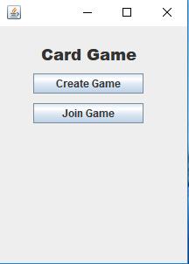The GUI should pop up and look like this --->
5. In order to create a game for you and your friends to play hit the Create Game
6. If one of your friends already created a game click Join Game
7. The creator of the Game should share the IP address that is shown on the top of the GUI
8. Players joining should type in the IP address given and a **different** port number then everyone else
9. Once everyone has connected the game will pop-up and look like this:

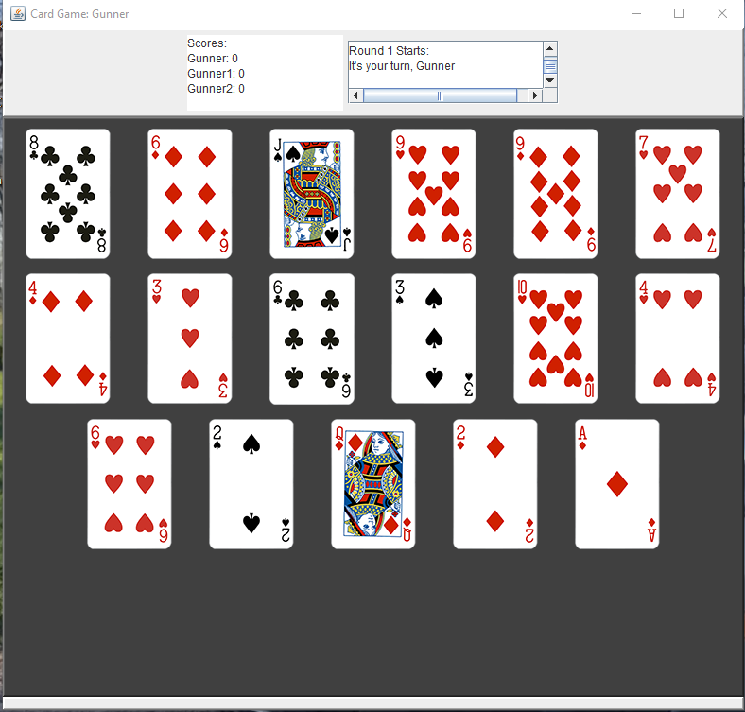

1. When it is YOUR turn all the cards will be colorful…. When it is NOT your turn the cars will be greyed out and you must wait for the other players to take their turn first
2. Click on a card to play it
3. Continue to play until all player have run out of cards
4. The player with the most points at the end of the game wins
5. At the end of the game click Play Again to play another round or click quit in order to exit the game
6. Thanks for playing our Card Game and Have FUN!